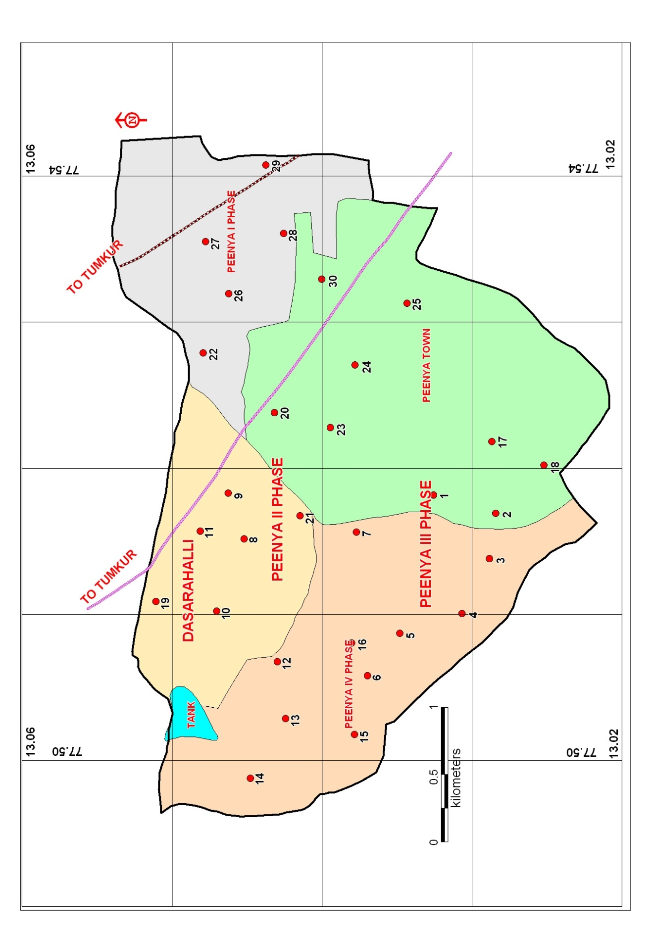

***Figure 1*.** Location map of Peenya Industrial Area with Sampling Stations

|  |  |  |  |  |
| --- | --- | --- | --- | --- |
| **Details of Sampling Stations along with the Latitude and Longitude** | | |  |  |
|  |  |  |  |  |
|  |  |  |  |  |
| Sample no. and code | Sampling Locations | Source | Latitude | Longitude |
| P1 | Aditya apparels, Peenya Istg, Peenya industrial area | BW | 77.5153 | 13.0175 |
| P2 | Vinayaka mosquito coil mfg co, Peenya industrial area | MWS | 77.5167 | 13.0177 |
| P3 | Opp Hitco tools ltd, III Ph, Peenya industrial area | BW | 77.5187 | 13.0249 |
| P4 | Rexroth Bosch India ltd, III Ph, Peenya industrial area | BW | 77.519 | 13.025 |
| P5 | Zuman exports, III Ph, Peenya industrial area | BW | 77.5188 | 13.0249 |
| P6 | Opp Shakthi mosaics, sanjay gandhi nagar slum, PIA | HP | 77.4617 | 13.0367 |
| P7 | Peenya industrial estate, bangalore north | HP | 77.523 | 13.0288 |
| P8 | Near super tax labels, II stage PIA | BW | 77.5061 | 13.0164 |
| P9 | Auma industried limited, II stage, Peenya dasarahalli | BW | 77.5078 | 13.0169 |
| P10 | Opp industrial electrocontrols, III stage, II Ph, peenya | MWS | 77.4572 | 13.0256 |
| P11 | Malnad furnitures, T-Dasarahalli, Peenya | BW | 77.4872 | 13.0236 |
| P12 | Near unique instruments, III main, IV Ph, PIA | HP | 77.513 | 13.0279 |
| P13 | Power plastics, III main, IV Ph, PIA | HP | 77.5161 | 13.028 |
| P14 | M/S Paragon footwear pvt ltd, Iiph, PIA | BW | 77.5283 | 13.0268 |
| P15 | Honeyhills energy system, PIA | BW | 77.5244 | 13.0397 |
| P16 | Fine tools India ltd, IV ph, PIA | BW | 77.5144 | 13.03 |
| P17 | Byraveshwara stores, nandini layout, I stage, II block | BW | 77.538 | 13.0136 |
| P18 | Petrol bunk, nandini layout | BW | 77.5367 | 13.0103 |
| P19 | Hi-power equipments pvt ltd, II ph, PIA | OW | 77.5161 | 13.0244 |
| P20 | M/S Biopharma drugs and pharmaceuticists, PIA | BW | 77.525 | 13.025 |
| P21 | Simco insulator manufacturing company, II ph, PIA | BW | 77.527 | 13.0261 |
| P22 | Hitachi koki India ltd, I ph, PIA | BW | 77.5189 | 13.0265 |
| P23 | Venus engineering industries, III ph, PIA | BW | 77.5172 | 13.0249 |
| P24 | Near shruthi innovations, Peenya | BW | 77.5356 | 13.033 |
| P25 | CMC-water Peenya | BW | 77.5383 | 13.032 |
| P26 | Hanuman weaving factory, I ph, PIA | MWS | 77.4928 | 13.0391 |
| P27 | Hind Hivac pvt ltd, I ph, PIA | BW | 77.5289 | 13.0405 |
| P28 | John crane sealing systems, I ph, PIA | BW | 77.5258 | 13.0389 |
| P29 | Trident fabricants, KIADB, I ph, PIA | BW | 77.4967 | 13.0367 |
| P30 | CMTI, Peenya | BW | 77.535 | 13.0325 |

BW: Borewell, OW: Open well, MWS: Mini water supply scheme, HP: Hand pump